**Library 2**

ECSE4235: Embedded Systems II

Small Project – 2024 – Timothy Million, Sreya Bitra



**Documentation**

**MultiRead**

The multiread function is designed to read multiple GPIO values at the same time, mimicking a bus.

uint16_t E4235_multiread (int [], int)

**Parameters:**

r0 → array of pin numbers

* If a series of numerically ordered pins are wanted, the format [#, ‘-’, #] can be used inside the array
* Cannot exceed 16 pins

r1 → length of the array

**Returns:**

The values of the multiple GPIOs being read. -1 is returned if invalid

**MultiWrite**

The multiwrite function is used to be able to write to multiple GPIO pins at the same time, mimicking a bus.

int E4235_multiwrite (int[], int, uint16_t)

**Parameters:**

r0 → array of pin numbers

* If a series of numerically ordered pins are wanted, the format [#, ‘-’, #] can be used
* Cannot exceed 16 pins
* If a pin is repeated the value is assigned to the second time will be written

r1 → length of the array

r2 → value to write

**Returns:**

-1 if invalid

**Appendix**

**E4235_multiwrite**

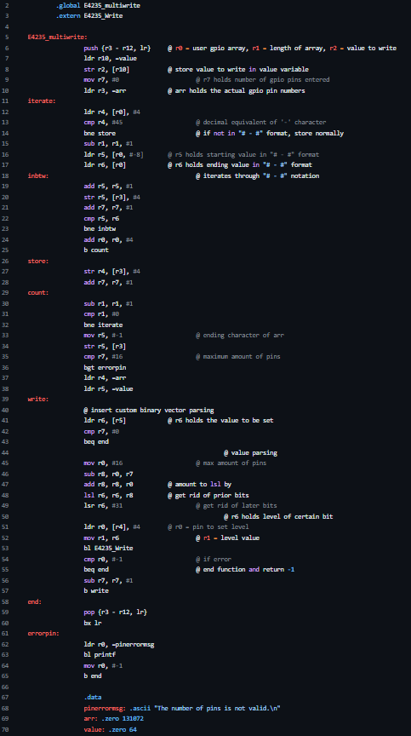

**E4235_multiread**

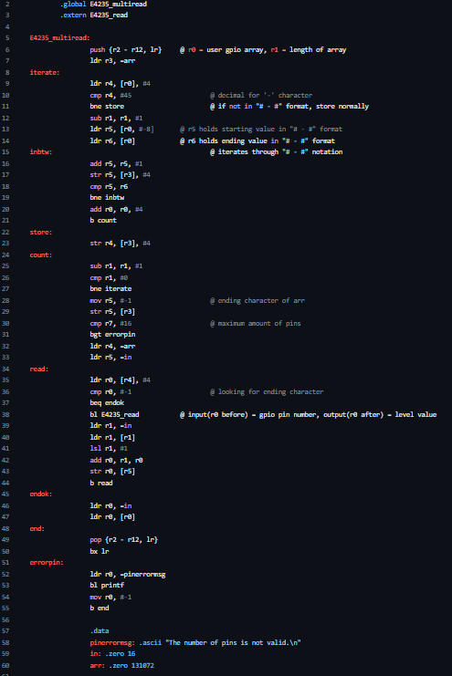

**multirw_ctest.c**

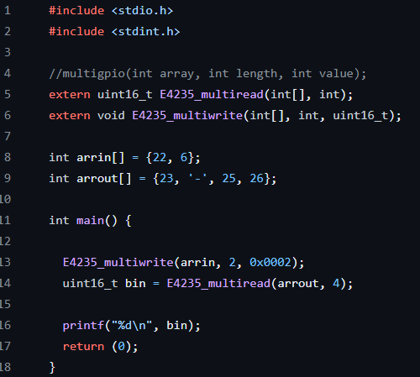

**multirw_asmtest.s**

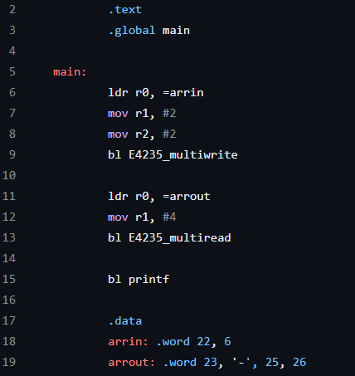

**Expected output of tests:** depending on how the pins are connected on the breadboard, the pins connected to GPIO_22 should read 1, and the pins connected toGPIO_ 6 should read 0

**References**

1. “BCM2711." Raspberry Pi Documentation, Raspberry Pi Foundation, <https://www.raspberrypi.com/documentation/computers/processors.html#bcm2711>.